Easy Recognition of a Commercial Drivers License (CDL) in New York Courts

- Court identification of CDL Cases can easily be identified upon filing by simply reviewing the License Class Box (shown below).
- The CDL/Bus/ Hazmat should also have indicators checked. It is required information when checking the CVH Box upon disposition in the Courtroom Software. (That information may be the determining factor in DMV determinination of a disqualification period.

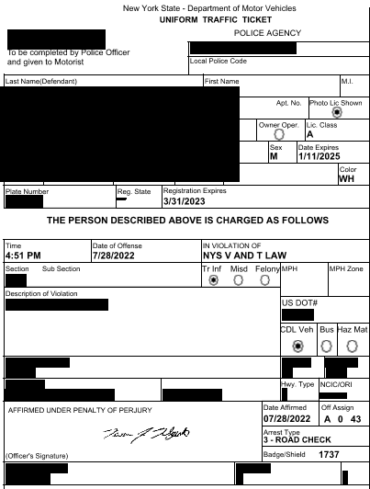
This is an additional indicator of a CDL requirement. Also refer to “M” 18 2008 below. The CDL Vehicle box may be showing Comm Vehicle.
Advise DMV if you receive tickets like this.
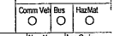
License Class
CDL A
CDL B
CDL C
(Be aware of the Non CDL Class C identified in the chart below.)

Driver License Types
https://dmv.ny.gov/driver-license/new-york-state-learner-permit-and-driver-license-class-descriptions
Refer to the table below for general New York State Driver License class descriptions.
Driver License Class Descriptions
Class | Qualifications | Eligible to Drive | Endorsements
A Commercial (CDL) | Age 21 or older  Legal presence in the United States  (18-20 - No interstate commerce. Cannot transport hazardous materials or operate a school bus.) | - Gross combination weight rating (GCWR) of more than 26,000 pounds, provided the gross vehicle weight rating (GVWR) of GCWR of vehicle(s) being towed is more than 10,000 pounds.  - Class B and C limited use motorcycles (mopeds). | H, M, N, P, S, T, W, X  Commercial Learner Permit (CLP) Limited to: M, N, P, S, W
B Commercial (CDL) | Age 18 or older  Legal presence in the United States  (18-20 - No interstate commerce. Cannot transport hazardous materials or operate a school bus.) | - GVWR of more than 26,000 pounds.  - May tow vehicles with a GVWR of 10,000 pounds or less OR may tow a vehicle of more than 10,000 pounds, providing the GCWR is not more than 26,000 pounds.  - Class B and C limited use motorcycles (mopeds). | H, M, N, P, S, W, X  Commercial Learner Permit (CLP) Limited to:  M, N, P, S, W
C Commercial (CDL) | Age 18 or older  Legal presence in the United States  (18-20 - No interstate commerce. Cannot transport hazardous materials or operate a school bus.) | - GVWR of more than 26,000 pounds that:  -Transports 15 or more passengers OR  -Transports passengers under Article 19-A of the V&T Law OR  -Stretch limousines OR  -Carries hazardous materials.  - May tow vehicles with a GVWR of 10,000 pounds or less OR may tow a vehicle of more than 10,000 pounds, providing the GCWR is not more than 26,000 pounds.  - Class B and C limited use motorcycles (mopeds). | H, M, N, P, S, W, X
C Non-Commercial | Age 18 or older | - GVWR of 26,000 pounds or less that doesn't require a CDL endorsement.  - May tow a vehicle with a GVWR of 26,000 pounds or less OR may tow a vehicle of more than 10,000 pounds, providing the GCWR isn't more than 26,000 pounds.  - Class B and C limited use motorcycles (mopeds). | F, G, W

